Product Requirements Document
IMU

Issued by | Role/Department | Date
Lorenzo Meloccaro | Electronics Team Member | 01/10/2025

TABLE OF CONTENTS
GENERAL PRODUCT DESCRIPTION 3
DESIGN 3
INTERFACE 3
ELECTRICAL HARDWARE AND SENSORS 3
TEST DA FARE 3
BOM 3
REPORT 3

GENERAL PRODUCT DESCRIPTION

Product Description
Key Features/ Functionality | The Inertial Measurement Unit (IMU) should read accelerations and angles during car’s motion sending Via CAN Bus reading of accelerometer, gyroscope and magnetometer
Software | n.a.
Other components Compatibility,  Ecosystem, etc. | CanBus
Working conditions | Ip60
Rules | n.a.
Dimensions and Tolerances | 44x42x11 cm
Weight | 60 g ca
Produzione | Aviorace
Connections | Connected via CanBus to the MCU

DESIGN
Renderings | 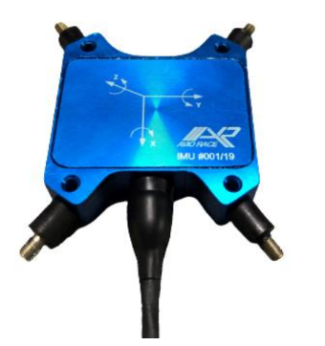  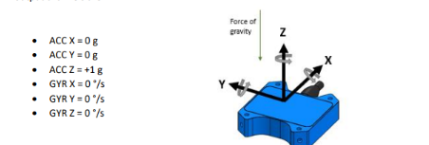

INTERFACE
Communication protocol | CanBus
Communication Input | N.a.
Communication output | CanBus
Connector | N.a.

ELECTRICAL HARDWARE AND SENSORS

Supply Voltage | 8-16 V
Supply Current | 20 mA
Input/Sensor Requirements | N.a.
Output/Actuator Requirements | Ax,Ay,Az  Gx, Gy,Gz  Mx, My, Mz
OverVoltage/ OverCurrent / Short Circuit Protection on power supply | N.a.
OverVoltage/ OverCurrent / Short Circuit Protection on output | Max 50 mA

BOM

Bill of material
BOM
Financials
BOM Cost

